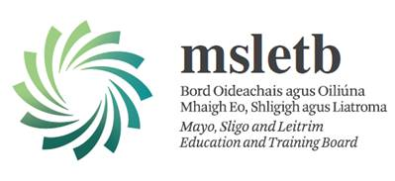CONSENT FORM – USING IMAGES UNDER 18

Name of Learner: ________________________

Occasionally, we may take photographs of our learners. We may use these images in our publicity, for example in the Training Centres prospectus or in other printed publications, as well as on our website or/and social media. To comply with the Data Protection Act 1998, we need your permission before we can photograph or make any recordings of your child. Please answer questions 1 to 4 below, then sign and date the form where shown.

PLEASE RETURN THE COMPLETED FORM TO THE MSLETB TRAINING CENTRE AS SOON AS POSSIBLE.

Please circle yes or no as appropriate

1. May we use your child’s photograph (unidentified) in the school prospectus and other printed publications that we produce for promotional purposes? Yes No

2. May we use your child’s image (unidentified) on our website and social media? Yes No

3. May we record your child’s image (unidentified) on video? Yes No

4. Do you consent to your child being photographed or filmed in press events agreed by the Training Centre? Yes No

Signed: …………………………………… Date: ………………… Name: …………………………………………………………………

(Parent) Unidentified above means we will only use the first name.