ETB Training Centre Guide to Claiming a QQI FETAC Common
Award Exemption
An ETB Training Centre requesting centre that is considering using the QQI FETAC exemption process for an ETB Training Centre learner with previous accredited learning i.e. where an ETB Training Centre learner holds an existing interim standard/NCVA component award, and is using it as part fulfilment of the criteria for a Major or Special Purpose Common Award, (Special Purpose Award must have multiple components) can do so only if the following conditions prevail:

- The ETB Training Centre must have a validated programme for that Common Award (major or special purpose) i.e. the ETB Training Centre are authorised to request certificates in respect of that Common Award.
- The request must consist of at least ONE Common Award Component. So it is feasible that requests for any Major, Special Purpose or Supplemental Common Award during the transition phase i.e. up-to the end of 2015, could consist of one Common Award Component and remainder made up of exemptions.
- From January 2016, only those awards which are no more than 5 years old, at the time the exemption is being sought, may be used to claim an exemption.

Note: The Award rules determination is made outside of the FBS, so it is important to ensure:
- That the Major/Special Purpose award rules including credit requirements are met
- That the supporting evidence is available for audit/monitoring purposes to support the request.

Procedure for Claiming an Exemption
Outlined below are the procedures for claiming an exemption where:
- There is a direct replacement in CAS and the replacement is included in the QQI FETAC Validated Programme for the ETB Training Centre use i.e. the exemption relates to a component that is mapped/ referenced in the latest version of the QQI FETAC publication “Managing Change to the Common Award system – An information note for Providers”

- There is no direct replacement CAS component and the proposed alternate is included in the QQI FETAC Validated Programme for the ETB Training Centre use i.e. the exemption relates to a component that is not directly mapped/ referenced in the latest version of the QQI FETAC publication “Managing Change to the Common Award system – An information note for Providers”

Claiming an exemption is a procedure carried out at requesting centre level when entering candidates for certification, the requesting centre must retain evidence in the form of a copy of the QQI FETAC transcript relating to the existing component award.
i. Where there is a direct replacement in CAS and the replacement is included in the QQI FETAC Validated Programme for the ETB Training Centre use i.e. the exemption relates to a component that is mapped/ referenced in the latest version of the QQI FETAC publication “Managing Change to the Common Award system – An information note for Providers”

Note: the conditions numbered 1 & 2 as outlined above (page 1) of this document, must be present before the following procedures are utilised:

- The course/project must sight and take a copy of the original QQI FETAC transcript for the component that the exemption is sought for and must sign the copy confirming that they sighted the original transcript.
- The course/project completes the QQI FETAC exemption form (see Appendix II).
- The course/project should verify the codes and titles against the reference list in the QQI FETAC publication “Managing Change to the Common Award system – An information note for Providers” (current latest version is “May 2013” - check web site for new up-dates).
- The course/project presents on behalf of the learner, the completed exemption form and a copy of the QQI FETAC transcript to the ETB Training Centre requesting centre (TSO) as part of the F12 supporting documents.
- The ETB Training Centre requesting centre as part of the Internal Verification of Results process checks that the exemption request is a valid request by checking;
- That the ETB Training Centre has a QQI FETAC approved validated programme leading to the specific Major or multiple component Special Purpose Common Award being requested.
- The Exemption form to ensure that a copy of the QQI FETAC transcript is attached and to verify the codes and titles against those mapped /referenced in the latest version of the QQI FETAC publication “Managing Change to the Common Award System – An information note for Providers”.

- Where there is no direct replacement CAS component i.e. the exemption relates to a component that is not directly mapped / referenced in the latest version of the QQI FETAC publication “Managing Change to the Common Award system – An information note for Providers”

Note: the conditions numbered 1 & 2 as outlined on page one of this document, must be present before the following procedures are utilised:

- Each situation is managed on a case by case basis in consultation with QQI FETAC. QQI FETAC will give consideration to such requests where it is the last opportunity for the learner to obtain a Major Award based on non-CAS awards.
- QQI FETAC QFBS requires adjustment to facilitate a request of this nature consequently approval from QQI FETAC is required prior to the generation of the F12. Copy of this approval should be included as part of the support documentation submitted with the F12.

Note: The following the process is only for results being processed through the RCCRS and includes the steps for recording exemptions in RCCRS and FBS:

Recording exemptions in RCCRS
Recording the exemption details in the RCCRS, the following is the procedure:
- If the exempted module is not listed for the class group in the RCCRS, the award has to be added by Logging a call on I.T. Helpdesk, select: “RCCRS” (call type), “Link Award for Exemption” (sub-type). Where the inputter is an external user (Contractor/Second Provider) you should complete the “RCCRS Exemption Request from Community Second Provider or Contracted Trainer to Temporarily Link Award to Facilitate Exemption Request Form” (see Appendix I) and submit to the Training Standards Office, who will arrange for this call to be logged on your behalf, note the component will only be available for a short period of time, to allow the result be inputted (for external users this is usually 1-2 days max). The external user will be notified via Training Standards Office the module is available for a result to be recorded.

- If the exempted module is listed for the class group in the RCCRS the inputter enters the result as “E” (for exemption). The details supporting this exemption must be recorded in the RCCRS and the process for doing this is as follows:

- The user Enters “E” as the grade and uses the “Result Details Screen” to enter the evidence by clicking on the result detail button (blue button with white arrow). See example below:



- The following data with the red asterisk * must be provided:

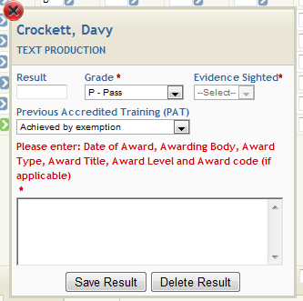
Result | Leave blank
Grade* | Select “E- Exemption”
Evidence Sighted* | Select “Yes” (evidence must be sighted)
PAT* (previous accredited training) | Select “Achieved by Exemption” Option
Evidence Sighted* | Select “Yes” (evidence must be sighted)
Complete text box with details of previous accredited training being used for the exemption – this text box must be completed with the details of the Award.
User clicks “Save Result”

- Save Result
Note that when the save result is entered, the inputter can only add information again for this learner in this “Result Detail Screen”, by exiting this screen and coming back in again as per (i) above.
Having saved the result it will show as follows:
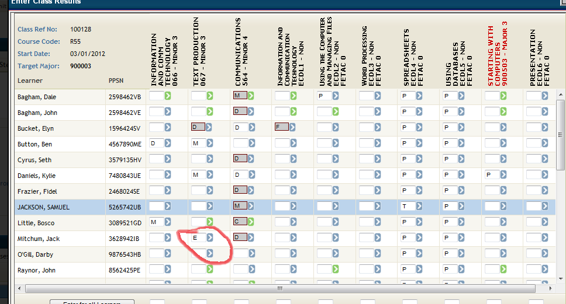

Note: As all exemptions have to be processed manually in the FBS, the recording of the exemption as an “E” result will, when up-loaded to the FBS, generate an invalid component record for this request. To amend the request in the FBS follow the steps below for recording exemptions in the FBS.

Recording exemptions in FBS
The learner request should now be in the Invalid Entries section, to move the learner from Invalid Entries into the Workspace, select a valid grade from the dropdown list and click ‘Submit’.
A valid grade must be appropriate to the award grading e.g. Pass. Note the grade itself doesn’t matter (as long as it is a minimum of a pass/successful result) as it merely facilitates the request to be moved out of Invalid Entries and into the Workspace to enable the manual requesting for an exemption.

After the request has moved from Invalid Entries then:
- Remove the grade/result entered
- Set Exemption to Yes
- Choose the appropriate Alternate from the list provided and submit
Example: the requesting centre should enter the learner for the component to be exempted e.g. 3N0575 (Recording Sales and Purchases), but instead of entering a result, should set Exemption to Yes and choose the appropriate Alternate from the list provided e.g. B05 (Cash Receipts).

Components achieved through exemption will be graded as ‘Exempt’ on a transcript. As the transcript displays the learner’s entire QQI FETAC award history, the original component used to achieve the exemption will also show on the transcript, with the relevant grade and date awarded.

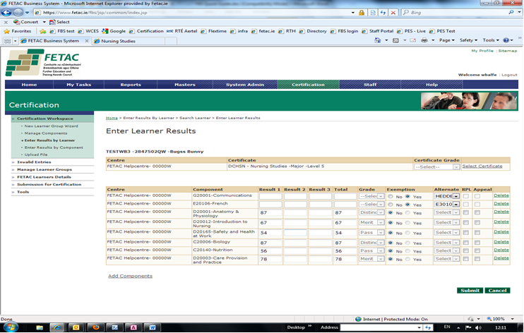

Appendix I

RCCRS Exemption Request from Community Second Provider or Contracted Trainer
to
Temporarily Link Award to Facilitate Exemption Request
(Please read the ETB Training Centre guide to claiming a QQI FETAC Common Award Exemption before completing this form)
Information required:
Second Provider or Contractor Name
Course Title
Course Code |  |  |  | Class Reference
Contact Name |  |  |  | Contact Phone Number
Contact name email address
Title of Exempted Award  (to be added to RCCRS) |  |  |  |  | Code of Exempted Award  (to be added to RCCRS)
This request can only be used for one class group/course at a time.
This request must be submitted via your local Training Standards Office, for the call to be logged to the ETB Training Centre I.T. Helpdesk as an attachment.
Training Standards Office Use only:
Logging the call on the ETB Training Centre I.T. helpdesk by:
Selecting: Call type “RCCRS”
Selecting: Sub-type “Link Award for Exemption”
Complete subject heading and summary of the request.
Include this attachment by clicking on “Log Call” on the next screen you are asked if you wish to add an attachment: Click on attachments and a pop-up window appears for you to source and attach the file. Click ok when done

Appendix II
QQI FETAC Exemption Claim Form

This form is to be completed by a centre if and when it is giving an exemption to a learner for a component where the learner has provided evidence of having achieved an acceptable alternate QQI FETAC or non QQI FETAC award. It should be completed and placed in the learner’s portfolio with a copy of the certificates/transcripts referred to. A copy of this form and the certificate/transcript should be forwarded to the Training Standards Officer, as soon as possible, at latest, prior to External Authentication.

Centre code and name:
Learner name and pps:
Certificate (major or special purpose award) Code and Title:
Assessor Name:

QQI FETAC Component to be exempted |  | Alternate QQI FETAC Component |  |  | Alternate non QQI FETAC award
Code | Title | Code | Title | Date  Achieved | Awarding Body | Award title | Date  Achieved

I confirm that I have seen the original certificate(s) / transcripts referred to in the list above. I have confirmed on the QBS that the alternate(s) can be used for exemption purposes.

_________________________________ _________________________
Assessor Date

